TITLE: ML LAB – 03: Descriptive Statistical Analysis
Student Name: Mahir Desai
Roll No: 23FE10CSE00345
------------------------------------------------
AIM
Apply statistical techniques to summarize, explore, and interpret datasets in a meaningful way before applying machine learning models.
------------------------------------------------
Experiment-1: Measures of Central Tendency & Dispersion
# Calculate all standard metrics
for col in num_cols:
print(df[col].mean(), df[col].median(), df[col].mode()[0])
print(df[col].min(), df[col].max(), df[col].sum(), df[col].var(), df[col].std())
Returned detailed summaries. E.g., Math Score: Mean (~66), Variance (~229), Std (~15).
Experiment-2: Quartiles
# Compute Q1, Median, Q3
Q1 = df[col].quantile(0.25)
Median = df[col].quantile(0.50)
Q3 = df[col].quantile(0.75)
Returned localized boundaries and IQR for Math, Reading, and Writing scores.
Experiment-3: Correlation and Covariance
corr_matrix = df[num_cols].corr()
cov_matrix = df[num_cols].cov()
Strong positive correlations identified (e.g. reading and writing score > 0.95). Covariance tracked structurally.
Experiment-4: Histograms & Boxplots
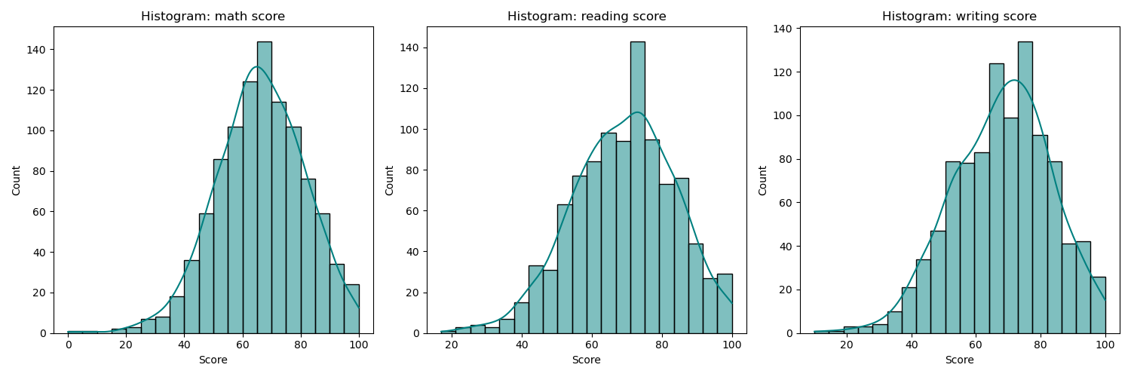
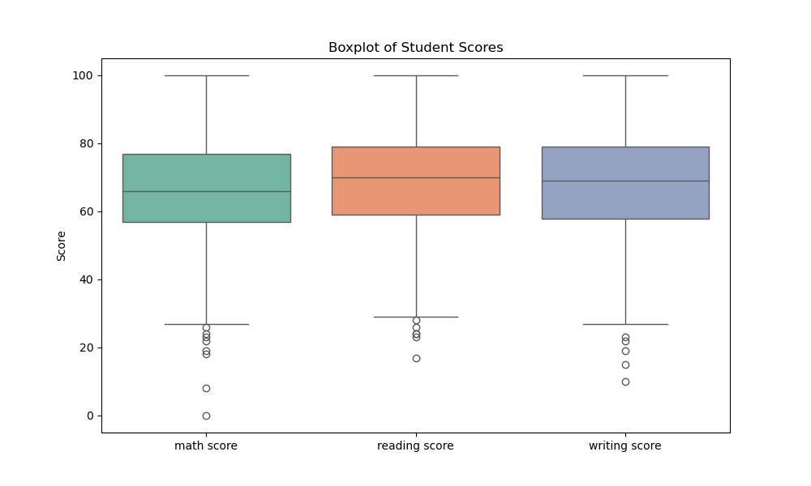
------------------------------------------------
Interpretations:
- The histograms show slightly left-skewed distributions, meaning the bulk of the scores are high, with a few exceptionally low scores trailing to the left.
- Boxplots reveal several outliers on the lower end for all three academic subjects.
- Reading and writing have incredibly tight correlation arrays compared to math mappings.

